Bahria University

Karachi Campus



Course: CSC-113-Web Engineering

Term: Spring 2018, Class: BSE- 6 B

Submitted By:

Zain Khan (40970)

Bushra Burney (40909)

Abid Ali (40898)

Project:

MESSAGING APPLICATION

Submitted To:

Engr. Majid Kaleem/Engr. Mobeen Nazar

Signed Remarks: Score:

Contents

INTRODUCTION 3

PROBLEM STATEMENT 3

EXISTING SYSTEMS 3

FEATURES 3

SOLUTION 3

OUTPUT 3

CONCLUSION 6

**MESSAGING APPLICATION**

# **INTRODUCTION**

The project is a messaging app where people can communicate with each other using a single URL.

## **PROBLEM STATEMENT**

Present messaging apps are not public and convey private messages. This app can be used publicly as a forum where various people can communicate through messages across the globe.

# **EXISTING SYSTEMS**

* WhatsApp
* Facebook Messenger
* Kik

# **FEATURES**

It allows multiple people to chat at the same time.

# **SOLUTION**

We provide a global forum to users across the world who can share their thoughts with each other without requiring to create chat groups and pages etc.

# **OUTPUT**

(Using Chrome)

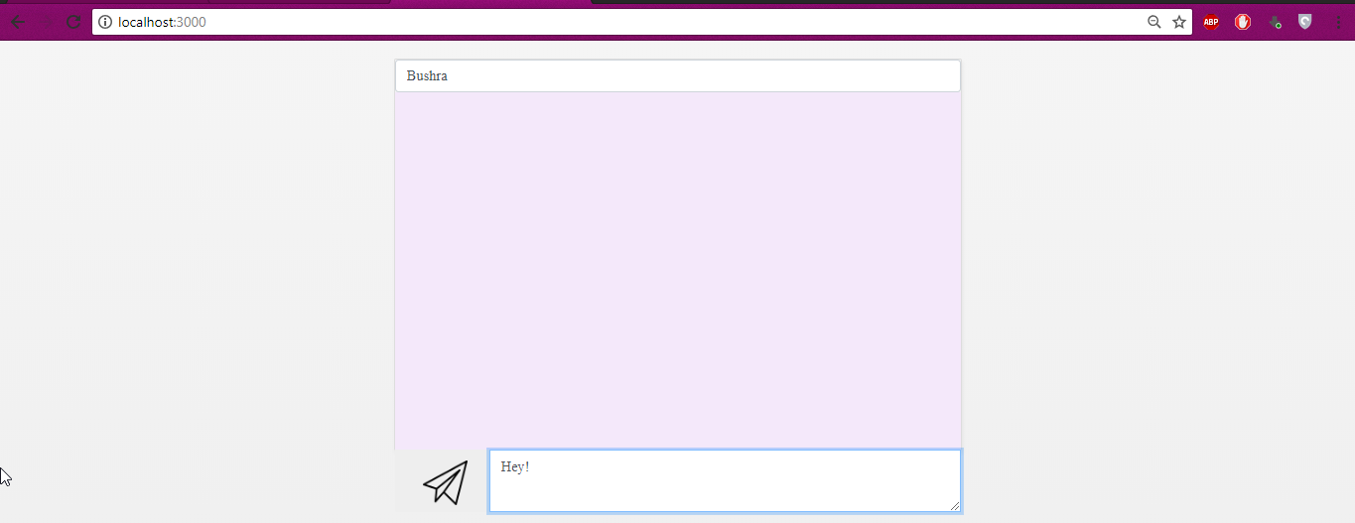

(Using Microsoft Edge)

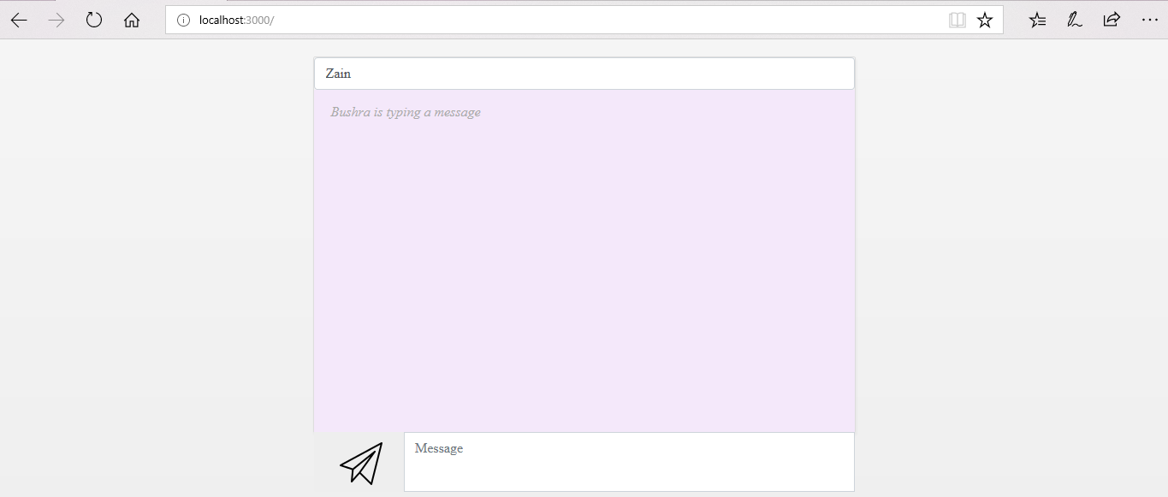

(Using Chrome)

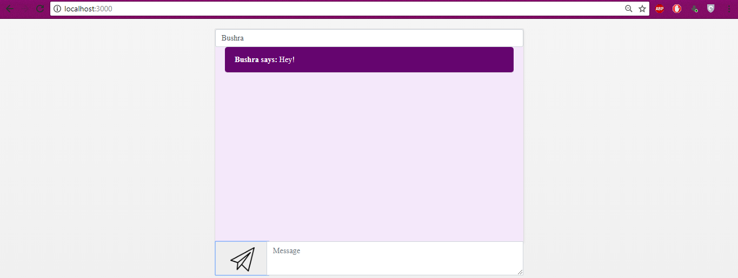

(Using Microsoft Edge)

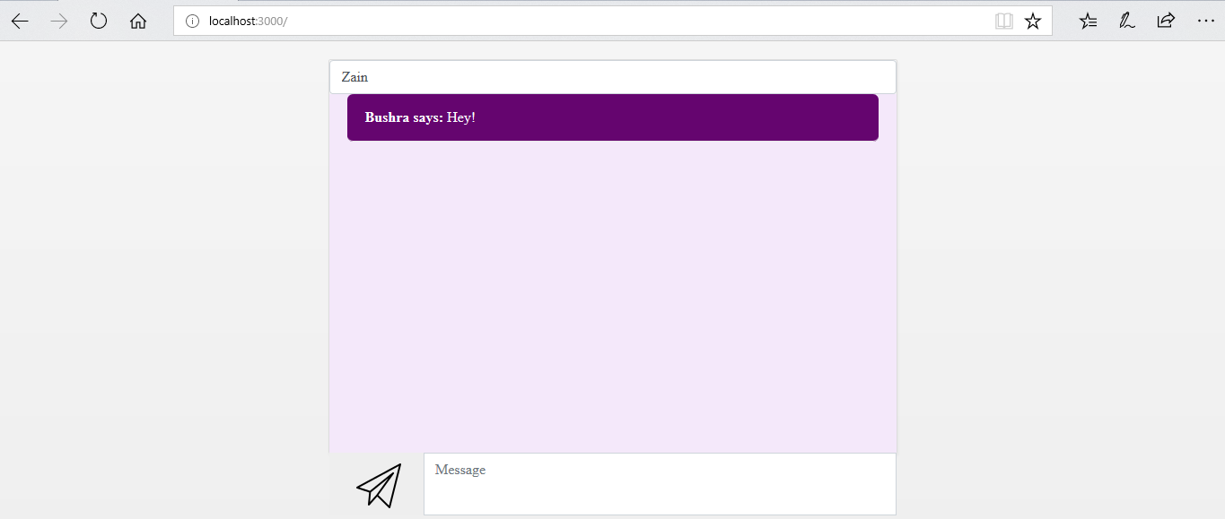

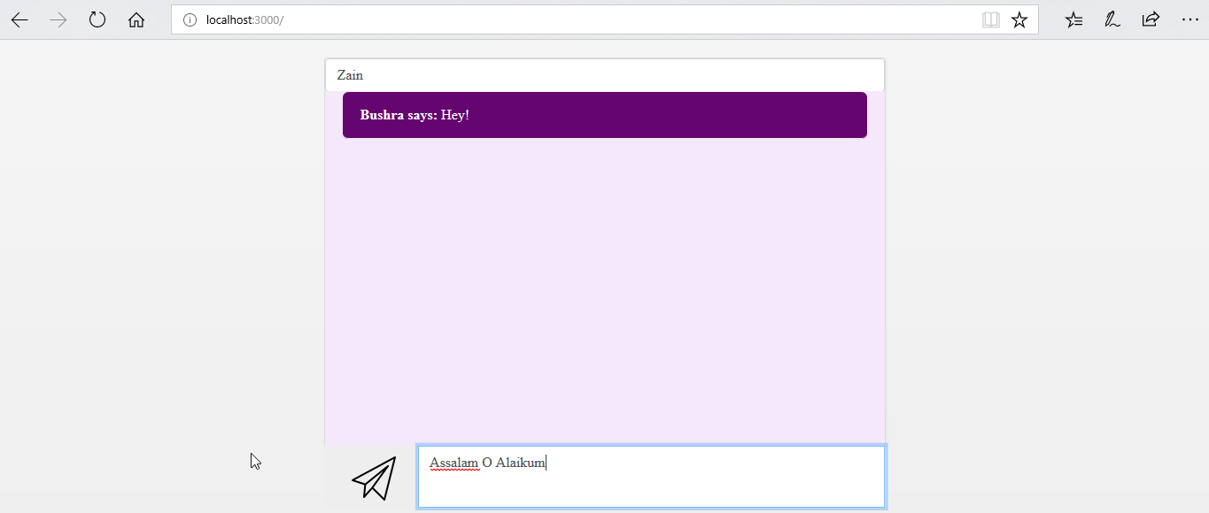

(Using Chrome)

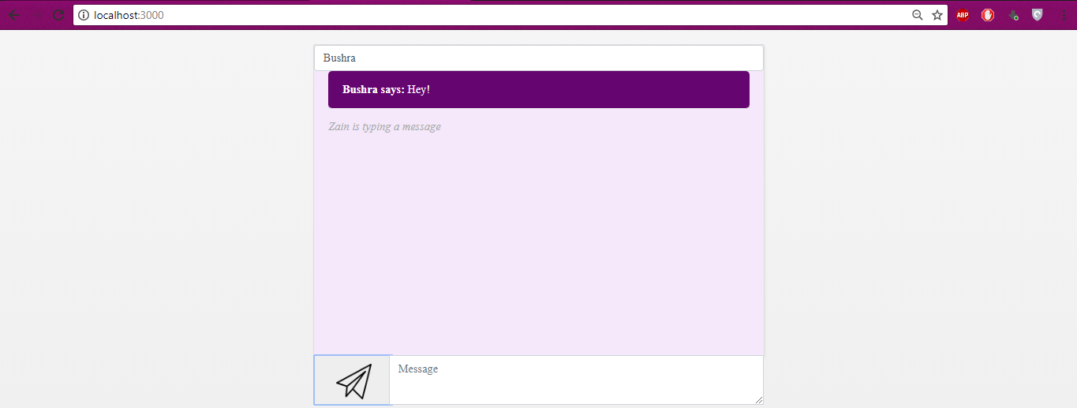

(Using Microsoft Edge)

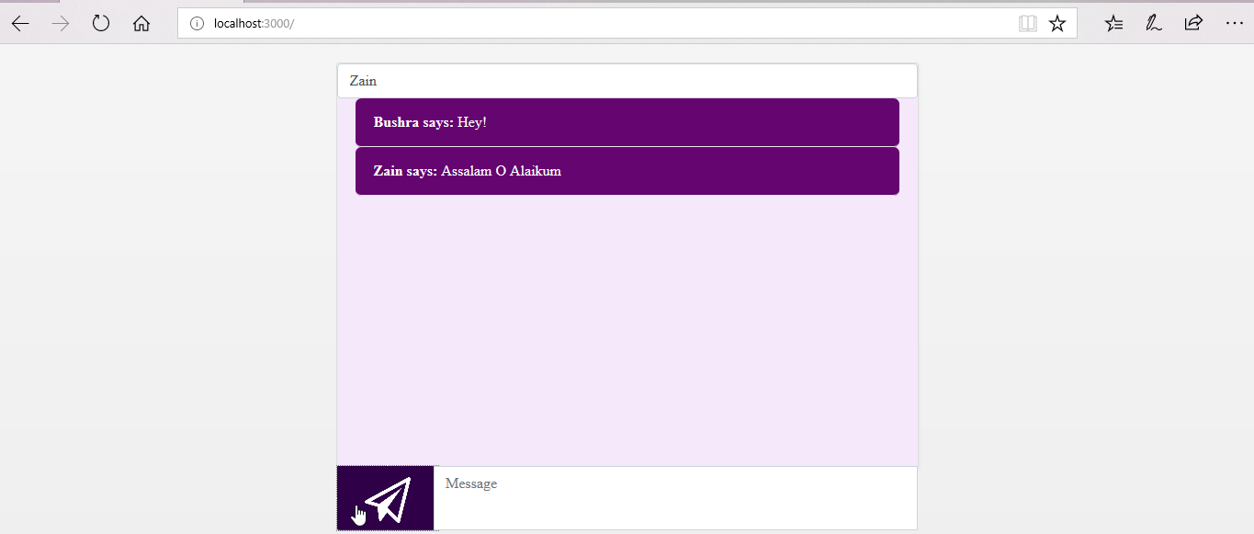

(Using Chrome)

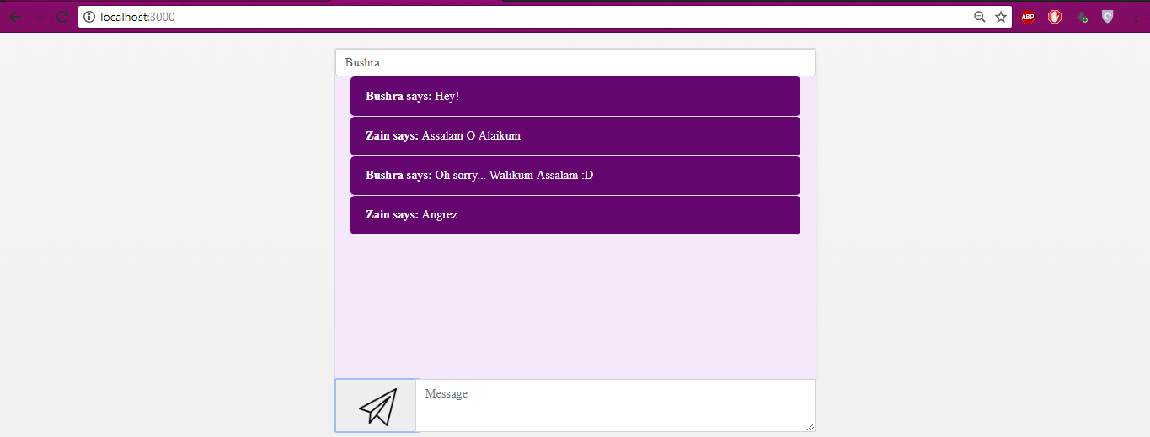

# CONCLUSION

This messaging app is useful if people want to publicly talk to each other and anyone with the link can join the conversation.